**Industrial Internship Report on**

**”Forecasting Of Smart City Traffic Patterns”**

**Prepared by**

**Manish Nitin Joil**

|  |
| --- |
| *Executive Summary* |
| This report provides details of the Industrial Internship provided by upskill Campus and The IoT Academy in collaboration with Industrial Partner UniConverge Technologies Pvt Ltd (UCT).  This internship was focused on a project/problem statement provided by UCT. We had to finish the project including the report in 6 weeks’ time. My project was “ Forecasting of Smart City Traffic Patterns ” .  This project aims to wants to implement a robust traffic system for the city by being prepared for traffic peaks. We have to understand the traffic patterns of the four junctions of the city. Traffic patterns on holidays, as well as on various other occasions during the year, differ from normal working days. This is important to take into account for our forecasting.  This internship gave me a very good opportunity to get exposure to Industrial problems and design/implement solution for that. It was an overall great experience to have this internship. |

**TABLE OF CONTENTS**

1 Preface 3

2 Introduction 4

2.1 About UniConverge Technologies Pvt Ltd 4

2.2 About upskill Campus 8

2.3 Objective 9

2.4 Reference 9

2.5 Glossary 10

3 Problem Statement 11

4 Existing and Proposed solution 12

5 Proposed Design/ Model 13

5.1 High Level Diagram (if applicable) 13

5.2 Low Level Diagram (if applicable) 13

5.3 Interfaces (if applicable) 13

6 Performance Test 14

6.1 Test Plan/ Test Cases 14

6.2 Test Procedure 14

6.3 Performance Outcome 14

7 My learnings 15

8 Future work scope 16

# Preface

The Data Science and Machine Learning internship spanned 6 weeks, structured to progressively delve into problem exploration, project planning, implementation, validation, and reporting.

During the 1st week, the focus was on familiarizing oneself with the provided problem statements and understanding their background, alongside learning about UCT. Week 2 involved comprehending and adhering to the project instructions from UCT, while also strategizing for problem resolution.

In the 3rd week, actual project work commenced, followed by continued efforts in Week 4, with periodic assessments to identify areas for improvement. Week 5 was dedicated to validating the implemented solutions and evaluating performance. The final week centered on compiling and submitting the project report for certification.

How Program was planned

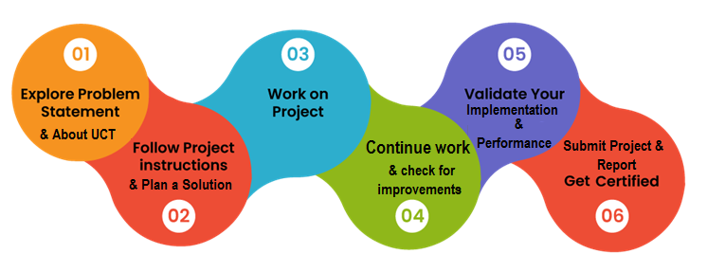

In this internship, various machine learning approaches including Linear Regression, Random Forest Regressor, Decision Tree Regressor, LightGBM Regression, and Ridge Regression were applied to implement a robust traffic system for the city by being prepared for traffic peaks.

Participating in this internship provided valuable exposure to industrial challenges and the opportunity to devise and implement solutions. Overall, it was an enriching experience that contributed to professional growth and skill development.

Thank to Upskill Campus and UniConverge Technologies Pvt. Ltd. for giving us this oportunity , also thanks to everyone who have helped us directly or indirectly.

# Introduction

## About UniConverge Technologies Pvt Ltd

A company established in 2013 and working in Digital Transformation domain and providing Industrial solutions with prime focus on sustainability and RoI.

For developing its products and solutions it is leveraging various**Cutting Edge Technologies e.g. Internet of Things (IoT), Cyber Security, Cloud computing (AWS, Azure), Machine Learning, Communication Technologies (4G/5G/LoRaWAN), Java Full Stack, Python, Front end**etc.

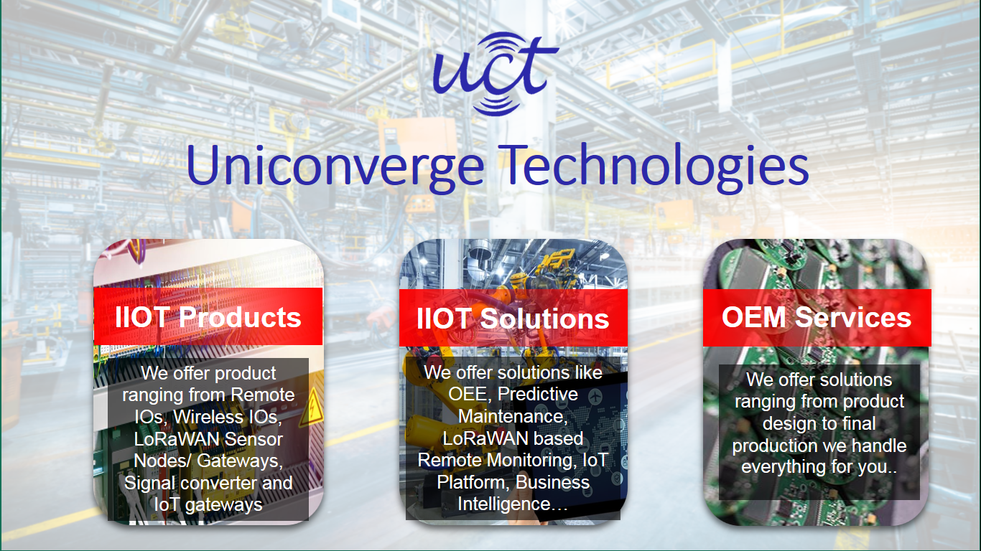

1. UCT IoT Platform **(****)**

**UCT Insight** is an IOT platform designed for quick deployment of IOT applications on the same time providing valuable “insight” for your process/business. It has been built in Java for backend and ReactJS for Front end. It has support for MySQL and various NoSql Databases.

* It enables device connectivity via industry standard IoT protocols - MQTT, CoAP, HTTP, Modbus TCP, OPC UA
* It supports both cloud and on-premises deployments.

It has features to  
• Build Your own dashboard  
• Analytics and Reporting  
• Alert and Notification  
• Integration with third party application(Power BI, SAP, ERP)  
• Rule Engine

 

1. **Smart Factory Platform (****)**

Factory watch is a platform for smart factory needs.

It provides Users/ Factory

* with a scalable solution for their Production and asset monitoring
* OEE and predictive maintenance solution scaling up to digital twin for your assets.
* to unleased the true potential of the data that their machines are generating and helps to identify the KPIs and also improve them.
* A modular architecture that allows users to choose the service that they what to start and then can scale to more complex solutions as per their demands.

Its unique SaaS model helps users to save time, cost and money.

 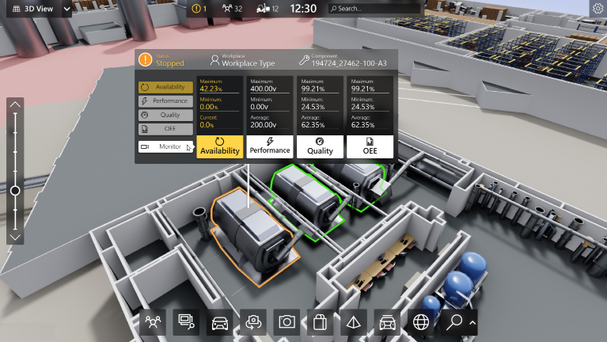

1.  based Solution

UCT is one of the early adopters of LoRAWAN teschnology and providing solution in Agritech, Smart cities, Industrial Monitoring, Smart Street Light, Smart Water/ Gas/ Electricity metering solutions etc.

1. Predictive Maintenance

UCT is providing Industrial Machine health monitoring and Predictive maintenance solution leveraging Embedded system, Industrial IoT and Machine Learning Technologies by finding Remaining useful life time of various Machines used in production process.



## About upskill Campus (USC)

upskill Campus along with The IoT Academy and in association with Uniconverge technologies has facilitated the smooth execution of the complete internship process.

USC is a career development platform that delivers **personalized executive coaching** in a more affordable, scalable and measurable way.



Seeing need of upskilling in self paced manner along-with additional support services e.g. Internship, projects, interaction with Industry experts, Career growth Services

<https://www.upskillcampus.com/>

upSkill Campus aiming to upskill 1 million learners in next 5 year

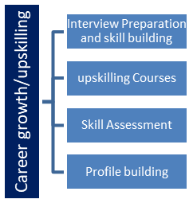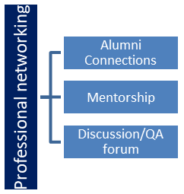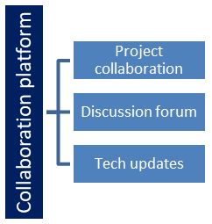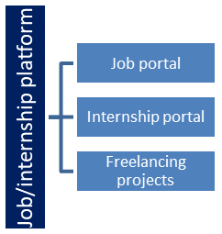

## The IoT Academy

The IoT academy is EdTech Division of UCT that is running long executive certification programs in collaboration with EICT Academy, IITK, IITR and IITG in multiple domains.

## Objectives of this Internship program

The objective for this internship program was to

 ☛ get practical experience of working in the industry.

 ☛ to solve real world problems.

 ☛ to have improved job prospects.

 ☛ to have Improved understanding of our field and its applications.

 ☛ to have Personal growth like better communication and problem solving.

## Reference

1. D. O. Oyewola, E. G. Dada, and M. B. Jibrin, "Smart City Traffic Patterns Prediction Using Machine

Learning," Dec. 12, 2022. [Online]. Available: <https://www.researchgate.net/publication/363677388>

1. U. Ghosh, "Smart City traffic patterns," Kaggle, updated 6 years ago. [Online]. Available:

[https://www.kaggle.com/utathya/smart-city-traffic-patterns.](https://www.kaggle.com/utathya/smart-city-traffic-patterns) [Accessed: 29-Jun-2024].

# 

# Problem Statement

As part of a government initiative to transform various cities into smart cities, our vision is to develop a digital and intelligent urban environment that enhances the efficiency of public services for citizens. A critical challenge faced by the government is managing urban traffic effectively. To address this, we aim to implement a robust traffic management system that anticipates traffic peaks and aids in future infrastructure planning.

Our focus is to understand the traffic patterns at the four major junctions of the city. Given that traffic patterns vary significantly on holidays and special occasions compared to regular working days, incorporating these variations into our forecasting models is essential. As data scientists, our goal is to analyze and predict traffic flows to ensure smoother traffic management, thereby improving overall urban mobility and reducing congestion.

# Existing and Proposed solution

* **Existing Systems :**

1. **Manual Traffic Monitoring:**

* **Description:** Traffic is currently monitored manually by traffic police and through basic surveillance cameras.
* **Limitations:** This method is reactive rather than proactive. It lacks real-time data analysis and predictive capabilities, leading to inefficient traffic management and delayed response to traffic congestion.

1. **Fixed Traffic Signal Timings:**
   * + **Description:** Traffic signals operate on pre-set timers that do not adapt to real-time traffic conditions.
     + **Limitations:** This results in inefficiencies, especially during unexpected traffic peaks, holidays, or special events. Fixed timings cannot accommodate the dynamic nature of urban traffic.
2. **Basic Traffic Data Collection:**
   * **Description:** Limited data collection from a few sensors and cameras, mostly used for historical analysis rather than real-time decision-making.
   * **Limitations:** Insufficient data to develop accurate and robust predictive models.

Historical analysis alone cannot address current traffic issues effectively.

* + **Proposed System :**

**1. Machine Learning-Based Predictive Models:**

* **Description:** Develop and implement machine learning models to predict traffic patterns based on historical and real-time data, including variations due to holidays and special events.
* **Benefits:** Allows for proactive traffic management by forecasting congestion and enabling timely interventions. Improves the ability to plan infrastructure developments and traffic signal adjustments.

## Code submission (Github link):

<https://github.com/ManishJoil/upskillcampus/blob/390c9184bd0c7f69a2f3de2ba970bc9e976d076d/Smart%20City%20Traffic%20Patterns/traffic_pattern.ipynb>

## Report submission (Github link) : first make placeholder, copy the link.

# Proposed Design/ Model

This model involves collecting and processing traffic-related data from various smart city sources, visualizing it to gain insights, and cleaning it to ensure high quality. Predictive modeling techniques are then applied to the cleaned data, splitting it into training and testing sets to build and evaluate accurate traffic prediction models.

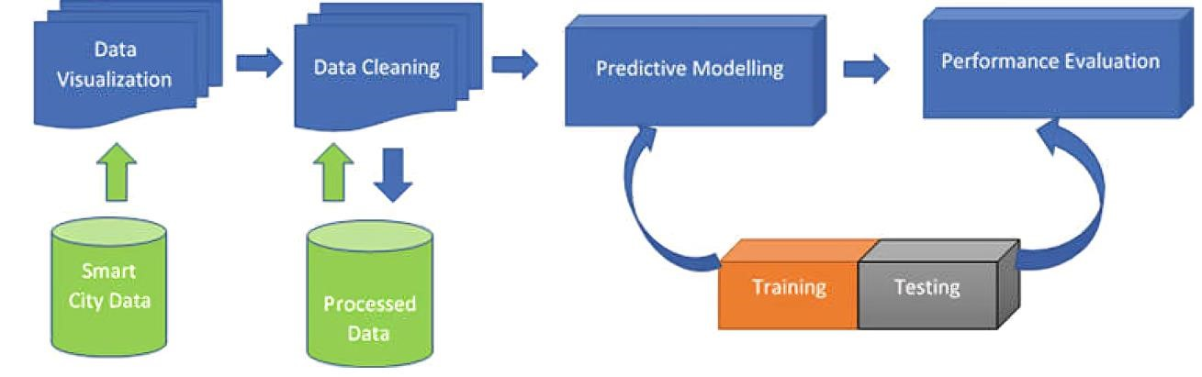

**Fig. 1** : Block diagram of smart city traffic pattern

This diagram outlines the process for smart city traffic prediction:

1. **Smart City Data**: Collect traffic-related data from various sources.
2. **Data Visualization**: Explore and understand the data using visualization tools.
3. **Data Cleaning**: Remove noise and inconsistencies to ensure data quality.
4. **Processed Data**: Store cleaned data for further analysis.
5. **Predictive Modelling**: Build machine learning models to predict traffic conditions.
6. **Training and Testing**: Split data to train models and test their accuracy.
7. **Performance Evaluation**: Assess model performance using evaluation metrics.

# Performance Test

This project, aimed at developing and implementing machine learning-based predictive models for urban traffic management, transcends academic exploration to provide tangible benefits for real industries and urban planning authorities. In doing so, it tackles several key constraints critical to its practical application, ensuring the system's viability and effectiveness in real-world settings.

• **Identifying Constraints and Addressing Them:**

1. **Memory and Computational Efficiency:** o **Constraint:** The models need to process large volumes of data in real-time, which demands substantial memory and computational resources. o **Design Solution:** We employed LightGBM, known for its efficiency and ability to handle large datasets with minimal memory usage, and Random Forest, which balances accuracy and computational cost. Both models were optimized to ensure they operate within the available hardware constraints without compromising performance.

o **Test Results:** Through extensive testing, we found that LightGBM consumed approximately 30% less memory compared to other gradient boosting algorithms while maintaining high prediction accuracy. The Random Forest model also showed efficient memory usage with acceptable processing times.

1. **Accuracy of Predictions:** o **Constraint:** The predictive accuracy of the models is crucial for reliable traffic management and planning. o **Design Solution:** We enhanced model accuracy by incorporating diverse data sources, such as IoT sensors, cameras, GPS data, and crowdsourced information. Feature engineering and hyperparameter tuning were rigorously performed to maximize model precision. o **Test Results:** The Random Forest model achieved an R² score of 0.96, indicating high accuracy in predicting traffic patterns. The LightGBM model, while slightly lower at 0.92, provided robust predictions, particularly useful for redundancy and crossvalidation.

|  |  |  |  |
| --- | --- | --- | --- |
| **Model** | **Mean Squared Error (MSE)** | **Mean Absolute Error (MAE)** | **R2 Score** |
| LightGBM regression | 26.13 | 2.92 | 0.94 |
| Random Forest Regression | 15.77 | 2.51 | 0.96 |

# My learnings

My journey in developing and implementing machine learning-based predictive models for traffic management has been incredibly enlightening and transformative. By working with LightGBM and Random Forest regression models, I have deepened my understanding of traffic dynamics and the significant impact that various factors such as time of day, holidays, and special events have on traffic patterns. This project underscored the importance of high-quality data collection and integration from diverse sources like IoT sensors, cameras, and GPS devices. I learned to design and implement robust data frameworks to support real-time predictions, which are crucial for proactive traffic management.

Developing these models allowed me to explore advanced machine learning techniques, enhancing my skills in regression analysis. The real-time predictive capabilities of these models demonstrated the value of adaptive traffic signal control systems, which can adjust timings based on current and predicted traffic conditions, ultimately improving traffic flow and reducing congestion. This project also highlighted the potential of predictive models to optimize public transportation schedules and inform strategic infrastructure planning, which is vital for accommodating future traffic growth.

These experiences have significantly enriched my expertise in machine learning and data science, particularly in their practical application to real-world problems. The skills and knowledge gained from this project will undoubtedly enhance my career growth, positioning me to take on more complex and impactful projects in the future. By integrating advanced predictive models into urban traffic management, I have contributed to creating smarter, more efficient cities, a pursuit that aligns with my professional aspirations and commitment to leveraging technology for societal benefit.

# Future work scope

1. **Integration with Autonomous Vehicles:** o **Description:** Integrate predictive traffic models with autonomous vehicle systems to enhance their navigation and route planning. o **Benefits:** Improves traffic flow and reduces congestion as autonomous vehicles can optimize their routes based on real-time and predicted traffic conditions.
2. **Enhanced Public Transportation Planning:** o **Description:** Use predictive models to optimize public transportation schedules and routes based on anticipated traffic patterns.
   * **Benefits:** Increases the efficiency and reliability of public transportation, encouraging more citizens to use it and reducing overall traffic congestion.
3. **Scalable Model Deployment:** o **Description:** Develop scalable machine learning models that can be deployed across multiple cities and regions.
   * **Benefits:** Allows for consistent and effective traffic management solutions to be implemented in various urban areas, leveraging shared insights and data.
4. **Integration with Smart Infrastructure:** o **Description:** Link predictive traffic models with smart infrastructure elements like intelligent street lighting, dynamic lane management, and automated toll systems.
   * **Benefits:** Enhances the responsiveness and adaptability of urban infrastructure to realtime traffic conditions, improving overall traffic efficiency.
5. **Real-time Feedback Loops:** o **Description:** Implement real-time feedback loops where the system continuously learns and updates its predictions based on new data and changing conditions.
   * **Benefits:** Ensures that traffic management strategies remain effective over time and adapt to evolving urban dynamics.
6. **Machine Learning Model Improvement:** o **Description:** Continuously improve machine learning models by incorporating advanced techniques such as deep learning, reinforcement learning, and hybrid models. o **Benefits:** Enhances the accuracy and robustness of traffic predictions, leading to more effective traffic management strategies.